UDACITY Data Analyst Nanodegree Program

**Project 01: Explore Weather Trends**

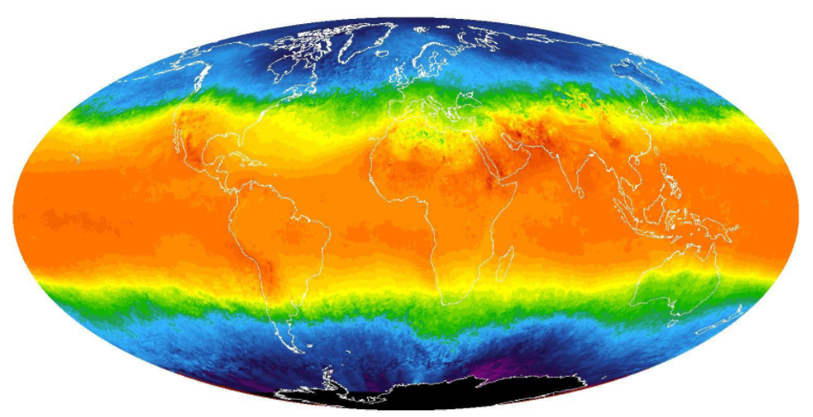

Project Submitted By:

**Sri Lakshmi Vadlamani**

**19 May 2019**

**Table of Contents**

**1.** **SQL Queries** 3

**2.** **Moving Averages** 5

**3.** **Data Visualization:** 6

**4.** **Data Interpretation:** 8

The following are the steps and tools used to prepare the data for visualization:

* 1. **Step 1**: Retrieved data using Postgres SQL
  2. **Step 2**: Calculated moving average in MS Excel
  3. **Step 3**: Plotted line charts for data visualization in MS Excel

# **SQL Queries**

Below are SQL queries employed to retrieve the data:

1. SQL query to check the nearest city in my country from “city_list.csv”

SELECT *

FROM city_list

WHERE country = 'Qatar'

city_list.csv:

|  |  |
| --- | --- |
| city | country |
| Doha | Qatar |

1. SQL query to extract the global data from “global_data.csv”

SELECT *

FROM global_data

global_data.csv: (limited to 9 rows)

|  |  |
| --- | --- |
| year | avg_temp |
| 1750 | 8.72 |
| 1751 | 7.98 |
| 1752 | 5.78 |
| 1753 | 8.39 |
| 1754 | 8.47 |
| 1755 | 8.36 |
| 1756 | 8.85 |
| 1757 | 9.02 |
| 1758 | 6.74 |

1. SQL query to extract the city level data “city_data.csv”

SELECT *

FROM city_list

WHERE country = 'Qatar' AND city = ‘Doha’

city_data.csv: (limited to 9 rows)

|  |  |  |  |
| --- | --- | --- | --- |
| year | city | country | avg_temp |
| 1843 | Doha | Qatar | 26.32 |
| 1844 | Doha | Qatar | 18.74 |
| 1845 | Doha | Qatar | 22.36 |
| 1846 | Doha | Qatar |  |
| 1847 | Doha | Qatar |  |
| 1848 | Doha | Qatar | 26.14 |
| 1849 | Doha | Qatar | 26.34 |
| 1850 | Doha | Qatar | 25.96 |
| 1851 | Doha | Qatar | 26.6 |

1. SQL query to join city data and global data to calculate moving averages “global_local.csv”:

SELECT global_data.year,

global_data.avg_temp AS global_avg_temp,

city_data.avg_temp AS doha_avg_temp

FROM global_data

JOIN city_data

ON global_data.year = city_data.year

WHERE city LIKE 'Doha';

global_local.csv: (limited to 9 rows)

|  |  |  |
| --- | --- | --- |
| year | global_avg_temp | doha_avg_temp |
| 1843 | 8.17 | 26.32 |
| 1844 | 7.65 | 18.74 |
| 1845 | 7.85 | 22.36 |
| 1846 | 8.55 |  |
| 1847 | 8.09 |  |
| 1848 | 7.98 | 26.14 |
| 1849 | 7.98 | 26.34 |
| 1850 | 7.9 | 25.96 |
| 1851 | 8.18 | 26.6 |

# **Moving Averages**

A 10-year moving average was calculated using **MS Excel** for global and local (Doha, Qatar) annual average temperatures. Moving averages was used to: (1) smooth out the annual average temperature data, (2) to remove any outliers, (3) filter out the “noise” from random annual movements and (4) identify overall trends in the data.

The formula used is ”= AVERAGE(number1, [number2], ...)”. Below is a screenshot of the MS Excel workbook:

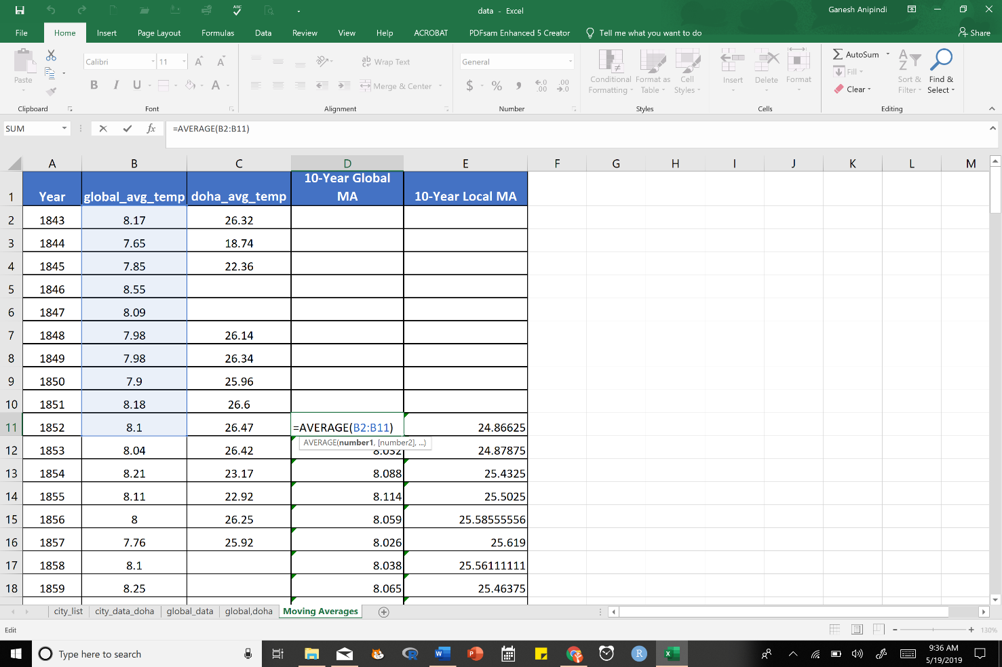

# **Data Visualization:**

The **key considerations** when deciding the data visualization for this project are, to:

* Demonstrate the trend
* Observe and record acceleration or deceleration of data over a period of time
* Observe volatility of global and local annual average temperatures over 171 years.

A line chart of the annual average temperatures (Fig. 1) and a 10-year moving averages (Fig. 2) are plotted using **MS Excel**. These charts compare average annual temperature in Doha (Qatar) with global records.



**Fig 1. Annual average line chart**



**Fig 2. 10-Year Moving average line chart**

# **Data Interpretation:**

Below are some observations derived from the dataset:

* Overall annual average temperatures in Doha (Qatar) are higher than the overall global average temperatures. This is probably because of the geographical location. This difference has been consistent over time.
* In the short term, both global and local temperatures are volatile, but in the long term, both display a slow increasing trend.
* The annual average global temperatures recorded a minimum of 7.56  ͦC in 1862 and a maximum of 9.73  ͦC in 2007. The percentage increase in annual average growth of temperature from 1862 to 2007 is 28.7%.
* The annual average temperature in Doha recorded a minimum of 18.74  ͦC in 1844 and a maximum of 29.7  ͦC in 1860. However, both these values seem to be outliers. The next lowest value is 23.56 in 1863 and the highest annual average temperature recorded was 28.93  ͦC in 2010. The percentage increase between 1863 and 2010 is 22.7%
* Both global and local temperatures show increase in average temperature with time, which means earth is getting hotter. However, the above percentage increases indicate that the global average temperatures are becoming increasingly warmer than the desert climates of Doha. This indicates significant global warming happening at an alarming rate.
* However, caution should be exercised in reading too much into this data as these are annual averages and more data points would be required to provide specific accurate and appropriate conclusions.